# Info Viz Project Guidlines :

## Data

So far, our dataset consists of one dataframe (one file .tsv) whose columns are:

|  |  |  |  |  |  |  |  |  |
| --- | --- | --- | --- | --- | --- | --- | --- | --- |
| **country** | **year** | **average** | **gini_index** | **cumul** | **high** | **low** | **share** | **width** |

It contains 64452 rows in total with.

Check the uploaded Notebook for the data clearning process “data_prep.ipyb”.

## Project:

As for the project, I have made a simple visualization based which displays two graphs (two dimensions: “country” and “year”).

Please find the GitHub repository link here:

## Remaining work:

Implement other graphs. Please refer to the following links in order to learn how to implement other graphs.

Non-exhaustive list of the DC charts:

<https://dc-js.github.io/dc.js/examples/>

Project using DC Js:

<http://dc-js.github.io/dc.js/>

Annotated Source code :

<http://dc-js.github.io/dc.js/docs/stock.html>

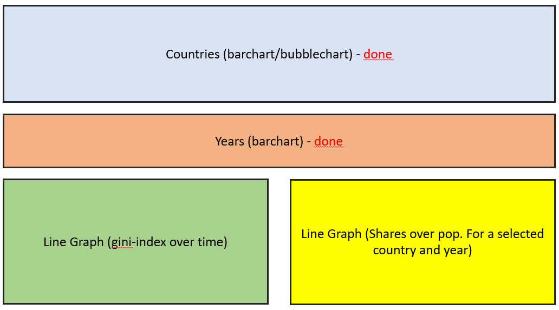

As for the comparison, we can refer to this (composite of timeseries – other solutions exist)

<https://dc-js.github.io/dc.js/examples/composite.html>